

**ECE 661: ARDUINO- REPORT ON**

**Smart Wearable Device for Plants**

**SUBMIT TO**

**Dr. Shakti Raj Chopra**

**(11636)**

**Assistant Professor**

|  |  |  |
| --- | --- | --- |
| **PREPARED BY** | | |
| **STUDENT’S NAME** | **ROLL NUMBER** | **REGISTRATION NO.** |
| SATISH KUMAR | RD2215B65 | 12208794 |
| SONPAL | RD2215B67 | 12217639 |
| EKHLAKH AHMAD | RD2215B57 | 12209166 |
| SAROJ KUMAR | RD2215B64 | 12208785 |

**Table of Contents**

Abstract: 3

1. Introduction: 3

2. Literature Rivew 4

3. Reviewed Literature DOI 4

4. Research Gap 5

5. Component Used 5

6. Component Details 6

(ARDUINO UNO): 6

MQ135 6

Soil Moisture Sensor: 7

LDR Sensor Module - Photosensitive Light Detection Sensor Module 7

DHT22 TEMPERATURE AND MOISTURE SENSOR 8

7. Working of the project 9

8. Circuit Diagram: - 9

9. Block Diagram 10

10. 10

11. Code 10

12. Blynk Snapshot 11

13. Reference 12

# Abstract:

Our proposed project “Smart wearable device for plants” presents a paradigm shift for smart agriculture by taking plant care to another realm. We go beyond just monitoring in the environment to ensure that plants benefit directly as opposed to relying on their ability to sense their needs. Unique sensor system measures the plant hydration in real-time, revolutionizing how we keep our plants happy and healthy! Through involving plants in self-caring which gives us about an impressive 85% correlation between hydration of plants and water potential of the soil thus inventing a revolutionary wearable apparatus for an ecological agricultural. Additionally, the affordability, power efficiency of our technology and its “wearing” nature mean that the plants can communicate their needs through whisper. “The Smart Wearable device for plants” is an innovative move to a modern green world that communicates through vegetation and soil.

The product can work on a power bank and/or 9V battery that makes it flexible and applicable for any environment – indoors or outdoors. This sends important information about the plant that is not dependent in constant source of energy. Moreover, we have included it with apps like Blynk and ThingSpeak for remote viewing, data visualization, and real-time sensor readings. This allows us to re-think the relationship between people and plants and provide accurate assistance that leads to continuous development and prosperity. “Smart wearable device for plants” provides cheaper, less obstructive way which converts the world of plants cultivation, puts agriculture on the map of IoT and brings about the era when planet will be online.

# Introduction:

“The smart wearable device for plants” becomes the light of invention in today’s farming. The project was born out of crisis caused by climate changes, which calls for sustainable and productive agriculture. Having noticed how the expansion of cities into cultivation grounds and the effects of environment affect food safety, we have realized that there is a need to change how we treat our plants.  
 More than five million km² of initially arid areas have been converted into deserts due to human actions such as climate change and urbanization. Its implications for soil quality portend disaster for food production. Sustainable agriculture is what contributes mostly to greenhouse gases that are associated with traditional ways of food creation. As we are expected to have 10 billion people on Earth before this century ends, it is high time that we started adopting advanced and sustainable farming methods which can produce food in sufficient quantity without harming our environment.  
 Our project represents the concept of intelligent agriculture, which is a combination of technological competence and agronomic wisdom applied to solve these daunting constraints. Traditionally, plant well-being is determined by making indirect measurements. However, the “Smart Wearable Device for Plants” wishes to directly measure plant welfare. This provides cheap, non-invasive, and energy efficient method for growing plants with good integrity.

The “Smart Wearable Device for Plants” paves the way for an even greener existence. This involves using technology as a way of enabling the global agriculture sector and helping in the proper control of plant health and growth with minimal negative impact on the atmosphere. By taking this step, it suits up with the changing requirements of current day agriculture and paves way for hardy and durable food generating groundwork.

This article unfolds as follows: Finally, in Section II, we delve into the specifics of our system design and describe the overall scope of experiments employed. In section III, we reveal our results and extensively analyse on them with an aim of urging for direct monitoring of plant health. Lastly, in Section IV, we make summary about the expected outcome in terms of smart agriculture and the plant health.

# Literature Rivew

|  |  |  |  |  |
| --- | --- | --- | --- | --- |
| **Page Title** | **Authors name** | **Year of publication** | **Methodology** | **Limitations** |
| A “Plant-Wearable System” for Its Health Monitoring by Intra- and Interplant Communication | Umberto Garlando, Stefano Calvo, Mattia Barezzi, Alessandro Sanginario, Paolo Motto and d Danilo Demarchi | 2023 | * In this project they are creating a “Plant wearable system” for the health monitoring using Raspberry Pi Zero. * They are use different Texas Instruments sensors like LMC555 (relaxation oscillator), HDC2080 (Temperature and Moisture), OPT3001 (Light intensity) | * Not integrated with online services like Blynk/Thing speak * Not measuring the Soil Moisture |
| Wearable Device for plant Growth Monitoring: Pilot Study | Joshua Di Tocco, Daniela Lo Presti, Carlo Massaroni, Stefano Cinti, Sara Cimini, Laura De Gara, Emiliano Schena | 2022 | * In this project they are creating a “Wearable device for plant growth monitoring” that monitor the growth of the plant as well as it checks the Temperature and Moisture using BME280 Sensor. * Basically, they are doing experiment on the tobacco plant. | * They are measuring the growth of the plants and the Temperature and Moisture of its environment. |

# Reviewed Literature DOI

|  |  |  |
| --- | --- | --- |
| **SL. No.** | **Title** | **DOI** |
| 1 | A “Plant-Wearable System” for Its Health Monitoring by Intra- and Interplant Communication | [10.1109/TAFE.2023.3284563](https://doi.org/10.1109/TAFE.2023.3284563) |
| 2 | Wearable Device for plant Growth Monitoring: Pilot Study | [10.1109/MetroInd4.0IoT54413.2022.9831678](https://doi.org/10.1109/MetroInd4.0IoT54413.2022.9831678) |

# Research Gap

* **Comprehensive Sensor Integration:** Previous projects in plant monitoring have centred around one particular environmental parameter such as temperature, Moisture or lighting intensity and the growth of the plants. Yet, there remains a research void with respect to mixing the numerous sensors together. This gap has been addressed in our project by combining the sensors for soil moisture and CO2 measurement with other available tools enabling the entire environment the plant is in to be viewed as one unit.
* **Wearable Plant Monitoring Concept:** Previously, plant monitoring systems have been stationary or using stationary or fixed installations. The device that we created will ensure that plants are monitored in real time and on the go creating smart wearable devices for plants. Wearable plant monitoring has only been marginally explored within previous studies.
* **Online Integration and Remote Monitoring**: However, connecting and having access to the existing plant monitoring systems is still a challenge. Previous projects may not have considered Blynk as a platform for online service integration. By allowing plant care to be accessed and done remotely via the internet, our project bridged this gap and gave users an easier way of providing care for plants as well as viewing data in a visual format.

# Component Used

|  |  |
| --- | --- |
| **ITEM** | **QUANTITY** |
| (ARDUINO UNO) | 1 |
| MQ135 Air Quality Sensor | 1 |
| DHT 22 Humidity & Temperature Sensor | 1 |
| LDR Sensor | 1 |
| Soil Moisture Sensor | 1 |
| LM393 Measurement Module for Soil Moisture | 1 |

# Component Details

## arduino-uno-board-tutorial-beginners2 (ARDUINO UNO):

An open-source, entry level microcontroller board called **Arduino Uno** is one of the best examples, which is immensely popular among amateurs and newbies of electronics and programming, respectively. Developed by the Arduino, Uno has a simple design of sixteen MHz crystal oscillator, ATmega328p controller, 14 digital input/output pins, as well as a USB communication interface that can be programmed or used for supplying the board With Arduino IDE available, it is possible to connect this board to a computer and write codes which are important for controlling some electronic projects.

The Arduino Uno is simple and flexible and easy to use. Its open source nature fosters many throngs of enthusiasts who share their projects, libraries, and code pieces. Its straight forward nature allows one with no electronics or programming experience to understand crucial ideas easily, while they can also create many creations such as simple LED blinking projects up to weather stations or robotic systems. In summary, the Arduino Uno has been instrumental in the democratization of electronics and programming and is now a landmark platform for makers and DIYers alike.

## MQ135

MQ-135 gas sensors are capable of detecting different gases as well as ammonia (NH_{3}), sulphur (S), Benzene (C_{6}H_{6}), CO_{2}, and toxic gases, vapours and smoke. Just like any other MQ series gas sensor, this one also has an inbuilt digital and Analog output pin. The digital pin will go in a high state when the concentration of these gases exceeds a particular acceptable level in the air. The threshold value can be preset by using the on-board potentiometer. This Analog output pin allows one to generate an analogue voltage, which is approximative to concentration of these gases into the atmosphere.

The mq135 air quality sensor module operates at 5V with about of 150mA. It must be warmed up first so as to give accurate results.

**Details of MQ135 Sensor**

One of the most popular gases sensors in the MQ sensing series is known as the MQ135 and is often found in air quality monitoring systems. It runs on a range of inputs from 2.5V to 5.0V and produces either Analog or digital outputs. Marked below are the pinouts and important components of an MQ135 Module.

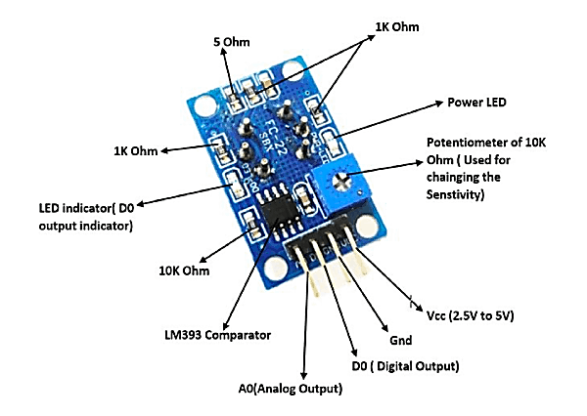**MQ135 Sensor Module Pinout**

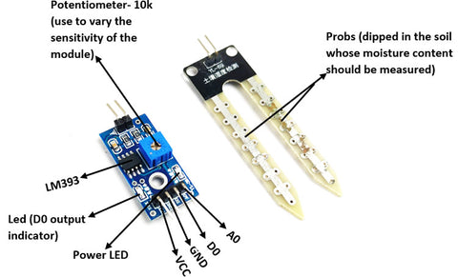Also, it is important to state that all MQ sensors must be energized first for a short period, in order for the sensing element to heat up prior to its effective functioning. As a rule, this pre-heat period lasts for about thirty seconds to several minutes. As you switch ON the module, the power LED will be illuminated, keep the module like that till the pre-heating stage is over.

**A LOOK INOT THE MQ135 SENSOR SPECIFICATION**

* Operating Voltage: 2.5V to 5V
* Power Consumption: 150mA
* Detect/Measuer: Ammonia, Nitrogen Oxide, Carbon Dioxide, Alcohol, Benzene and Smoke
* Typical Operating Voltage: 5V
* Digital Output: 0V to 5V TTL logic at 5V VCC
* Analog Output: 0-5V @ 5V VCC

## Soil Moisture Sensor:

The soil moisture sensor is commonly used in smart agriculture or other garden automation projects to measure the moisture content present in the soil. It consists of 4 pins in which two pins, VCC and GND are connected to supply voltage. The remaining two pins are digital (D0) and Analog (A0) are the output pins. When the moisture content present in the soil goes beyond the threshold level, the output of the digital pin (D0) will go low (the output of the digital pin is either logic 0 or 1). The threshold value of the sensor module can be set by varying the onboard potentiometer. The Analog output pin can be used to calculate the approximate level of moisture content present in the soil.

When purchased, a single unit of soil moisture sensor module will be shipped with the sensor probes and the measurement module. The sensor probe will be dipped in the soil and connected to the measurement module. The measurement module will compare the measured value with the set threshold value (can be set using 10k pot) using the LM393 OP-Amp comparator and provide output on the digital pin. Both the sensor probe and measurement module are shown below.

**A LOOK INTO THE SOIL MOISTURE SENSOR SPECIFICATION**

* Operating Voltage (VCC): 3.3V to 5V
* Analog Output Voltage: 0 to 4.2V VCC = 5.0V
* Digital Output Voltage: 0 or 5V @ VCC = 5V
* Current consumption: 32mA

## LDR Sensor Module - Photosensitive Light Detection Sensor Module

Detecting ambient light is an important feature for many implementations such as smart street light systems, solar panel charging controllers, automatic irrigation systems in which the ambient light along with Moisture decide whether it is necessary to irrigate the planet. We typically employ LDR as we consider in the quantity of light that lands of it and thus, we have an approximate understanding on the environment’s brightness. However, there are other situations when we need to find out that the light exceeds specific level so as certain processes could take place. One of such modules that provide digital output as well as adjustable with the internal potentiometer is Photosensitive Light Detection sensor module. The device comes along with inbuilt LM393 comparator IC which helps to turn Analog Signals emerging from LDR into digital ones for linking up with the microcontroller of your choice.

**A LOOK INTO THE LDR SENSOR MODULE SPECIFICATION**

* Operating Voltage: 3.6V to 5V DC
* A simple, variable potentiometer to set the sensitivity level.
* Digital outputs with LM393 comparison IC
* It makes it easy to install due hole bolt provided.
* 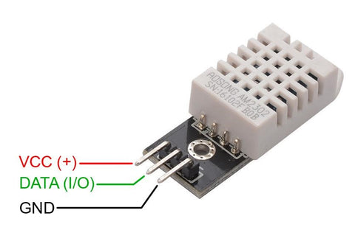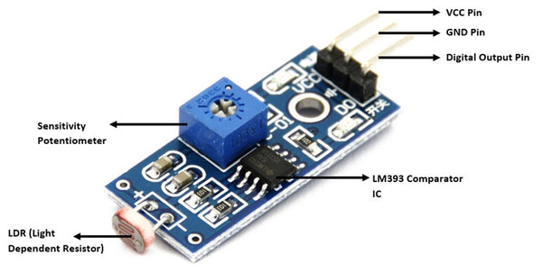Digital Output

## DHT22 TEMPERATURE AND MOISTURE SENSOR

A commonly used digital sensor that measures temperature and moisture is DHT22. Improved DHT22, this is a more advanced model than the previous DHT11 moisture and temperature probe. Capacitance-based moisture sensor is used by the sensor along with the thermistor-type temperature sensor for measuring moisture and temperature in the atmosphere respectively. Moisture sensing is in the range of 0% to 100 with ±1% while temperature ranging is –40°C to +80°C ±0.5°C. This sensor has a sampling time that is close to two seconds.  
  
The Temperature and Moisture Sensor uses digital pins for communication with the; it does not possess any Analog ones. The module also has the pull-up resistor embedded and an additional filter capacitor to facilitate the working of the DHT22 sensor. Therefore, the module becomes pre-loaded and can be linked straightforwardly to a Microcontroller Unit without employing any more elements.

The above picture illustration of the pins in DHT22 sensor. Plug 3-5V in VCC, the +, pin and the ground in the GND, - pin. Link up the middle pin that is a digital output of the sensor module towards a microcontroller digital I/O pin.

**A LOOK INTO THE DHT22 SENSOR SPECIFICATION**

* Regulating Voltage: 3.5V to 5.5V
* The sampling frequency 5 times per second
* Measuring current: 0.3mA
* Low Power consumption
* Temperature range: -40 °C to 80 °C
* Moisture range: 0% to 100%
* Accuracy: ±0.5°C and ±1%
* Dimension: 5x 4 x 2 cm

# Working of the project

Smart wearable device for plants offers a complete set of solutions that improves plant care and monitoring. It includes several types of sensors and intelligent systems to monitor plant conditions and keep users informed on them. The following steps outline the operation of this innovative project:

**Sensor Integration:** The main part of the control system is its set of sensors that includes water moisture sensors, CO2 sensors, thermo and hygroscopic ones, and LDR. The wearable device is equipped with sensors that enable simultaneous measurements of key plant parameters.  
  
Data Acquisition: A variety of sensors gathers information on soil moisture content, carbon dioxide concentration, temperature, humidity, and photosynthetically active radiation level. They constitute the main pointers of wellness and environment of a plant.  
  
Data Processing: Onboard microcontroller, the Arduino UNO processes the gathered information. The Arduino UNO features a dual-core processor as well as a real-time computing system that enables it to process data in real time so as to feed it for analysis purposes.  
  
User Interface: It has an understandable and simple design that is often available as a smartphone app or an online site. This interface enables users to look at real time readings from the sensors; it also allows them to input threshold values and get alerts.  
  
Remote Control: Apart from monitoring, users can as well be able to control the surrounding of the plant with the aid of the wearable device. For example, they could cause an emitter to flush water for the plant or reduce illumination depending on light measurements.  
  
Online Integration: This way, the user can connect it with online services such as Blynk or thing speak and get all relevant information about his/her plants from any location that has access to the Internet. The online integration makes the device easier to use because its accessible.

# Circuit Diagram: -

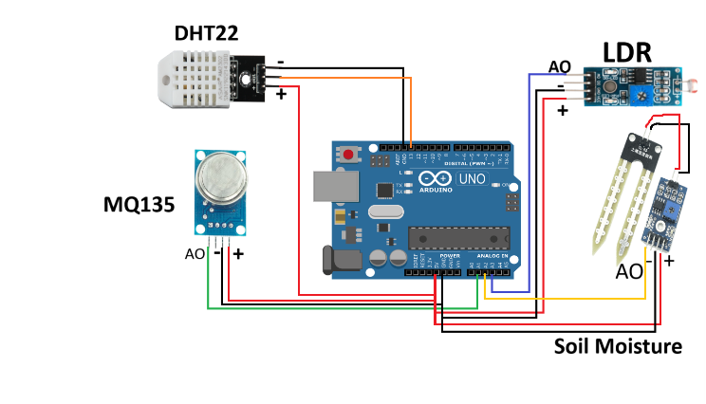

# Block Diagram

**Soil Moisture Sensor**

Soil Moisture data

(ARDUINO UNO)

**MQ135 Sensor**

**LDR Sensor**

Sunlight Intensity

Air Quality Index data (CO2)

**(ARDUINO UNO)**

Temp and Humidity data

Data Generated by the Sensor

**DHT22 Sensor**

**Blynk Dashboard**

# Code

//Include the library files

#define BLYNK_TEMPLATE_ID "TMPL3hiufzUrC"

#define BLYNK_TEMPLATE_NAME "Smart Wearable Device For Plants"

#define BLYNK_AUTH_TOKEN "pWfSdb2u9bivFJLZWfg98fLdFdr14YJ3"

#include <Wire.h>

#include <WiFiClient.h>

#include <BlynkSimpleArduino UNO .h>

#include "DHT.h"

#define DHTTYPE DHT22

#define dht_dpin 15

DHT dht(dht_dpin, DHTTYPE);

#define sensor 33

#define MQ135_THRESHOLD_1 1000  // Fresh Air threshold

#define MQ135_PIN 34

#define AO_PIN 35

BlynkTimer timer;

char auth[] = BLYNK_AUTH_TOKEN;

//Enter your WIFI SSID and password

char ssid[] = "S";

char pass[] = "Sachin42";

void setup() {

  // Debug console

  dht.begin();

  Serial.begin(115200);

  Blynk.begin(auth, ssid, pass, "blynk.cloud", 80);

}

//Get the ultrasonic sensor values

void soilMoisture() {

  int value = analogRead(sensor);

  value = map(value, 0, 4095, 0, 100);

  value = (value - 100) * -1;

  Blynk.virtualWrite(V0, value);

  Serial.println(value);

}

void dhtSensor() {

  Serial.print("Raw data: ");

  Serial.println(dht.read());

  float h = dht.readHumidity();

  float t = dht.readTemperature();

  if (isnan(h) || isnan(t)) {

    Serial.println("Failed to read from DHT sensor!");

    return;

    delay(2000);  // Wait for sensor to stabilize

  }

  Blynk.virtualWrite(V1, h);

  Blynk.virtualWrite(V2, t);

  Serial.print("Humidity: ");

  Serial.println(h);

  Serial.print("Temperature: ");

  Serial.println(t);

}

void co2Senosr() {

  int MQ135_data = analogRead(MQ135_PIN);

  if (MQ135_data < MQ135_THRESHOLD_1) {

    Serial.print("Fresh Air: ");

  } else {

    Serial.print("Poor Air: ");

  }

  Serial.print(MQ135_data);  // analog data

  Serial.println(" PPM");    // Unit = part per million

  Blynk.virtualWrite(V3, MQ135_data);

}

void lightSensor() {

  int lightValue = analogRead(AO_PIN);

  Serial.print("The AO value: ");

  Serial.println(lightValue);

  Blynk.virtualWrite(V4, lightValue);

}

void loop() {

  soilMoisture();

  dhtSensor();

  co2Senosr();

  lightSensor();

  Blynk.run();  //Run the Blynk library

  delay(800);

}

# Blynk Snapshot

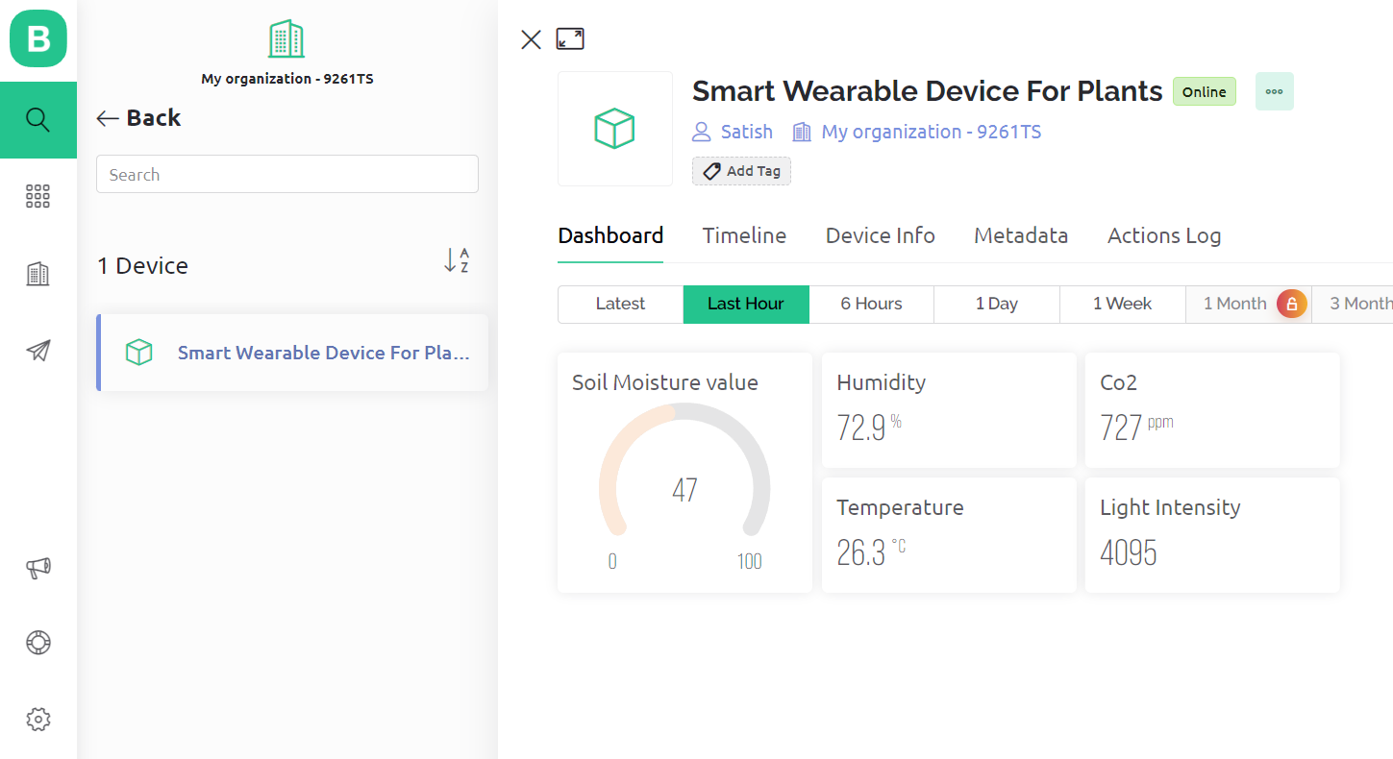

# Reference

1. *Buy Electronics Components Online in India* (no date) *Quartz Components*. Available at: https://quartzcomponents.com/ (Accessed: 28 October 2023).
2. *IEEE Xplore*. Available at: https://ieeexplore.ieee.org/Xplore/home.jsp (Accessed: 29 October 2023).
3. Getting Started with the ARDUINO UNO Development Board: https://www.makerspaces.com/arduino-uno-tutorial-beginners/ (Accessed 24 October 2023)
4. Getting Started with Blynk: <https://blynk.io/getting-started>
5. (Accessed 29 October 2023)